For Questions 1-15, read the text below and decide which answer A, B, C or D best fits each space.

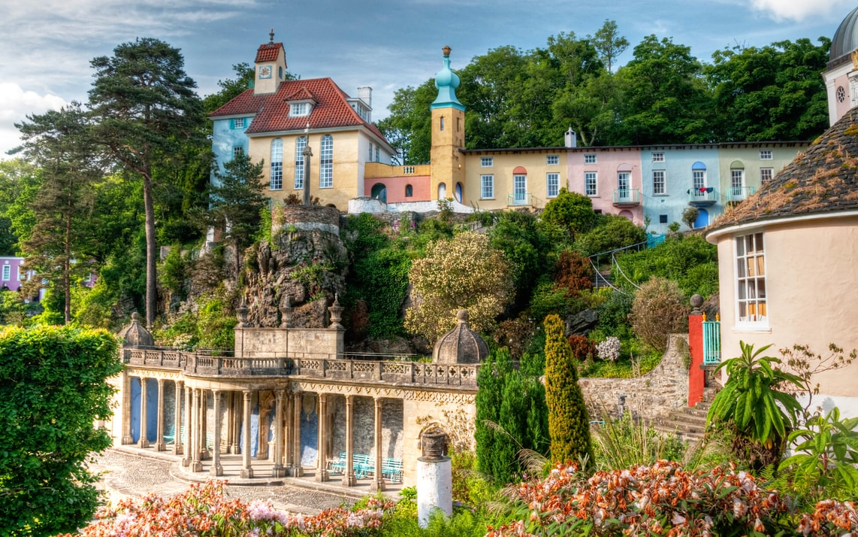
AN ITALIAN VILLAGE IN WALES

The ₍₀₎ ___ in North Wales is magnificent and so this area is very popular with tourists. Situated on a dramatic part of the rocky coastline is a village, ₍₁₎ ___ in Britain, called Portmeirion. The dream of the architect Clough Williams-Ellis, its construction began in 1925 and he finally ₍₂₎ ___ in finishing the ₍₃₎ ___ in 1973. The result is a copy of a small, and very beautiful, Italian village
As you wander down the ₍₄₎ ___ paths towards the village you can ₍₅₎ ___ the sea through the trees, and there is a marvellous ₍₆₎ ___ of the whole coastline from the top of the church tower. ₍₇₎ ___ the houses, shops and restaurants, there is a luxury hotel, which seems, at ₍₈₎ ___ tide, almost to float on the water.
Most of the houses are ₍₉₎ ___ to visitors in the summer months, ₍₁₀₎ ___ a few people do live in Portmeirion all year ₍₁₁₎ ___. It is possible for ₍₁₂₎ ___ to visit the village for the day ₍₁₃₎ ___ payment of a small entrance ₍₁₄₎ ___. Late spring and early autumn are the best times to visit, ₍₁₅₎ ___ in the early morning when the only sound that can be heard is the splashing of the water in the fountains.

0 A territory B scenery C setting D land
- A single B unique C particular D only
- A succeeded B managed C resulted D achieved
- A task B attempt C effort D labour
- A curling B winding C rolling D waving
- A glimpse B glance C look D catch
- A display B view C sight D outlook
- A As well B More than C In addition to D Apart
- A complete B big C maximum D high
- A charged B paid C let D borrowed
- A although B otherwise C even D despite
- A by B along C round D down
- A spectators B onlookers C observers D sightseer
- A in B over C from D on
- A ticket B fee C fare D subscription
- A particularly B exactly C precisely D distinctly

